# HDFS

## NameNode内存估算

As a rule of thumb, each file, directory, and block takes about 150 bytes.

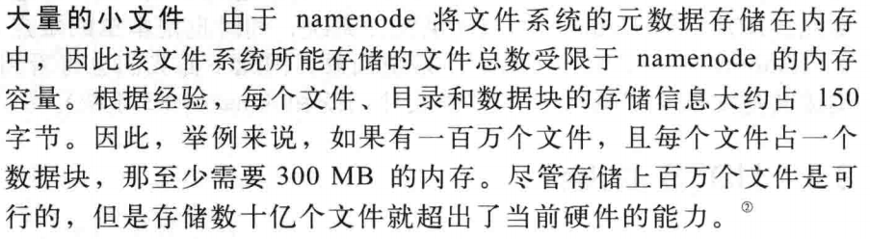

How Much Memory Does a Namenode Need?

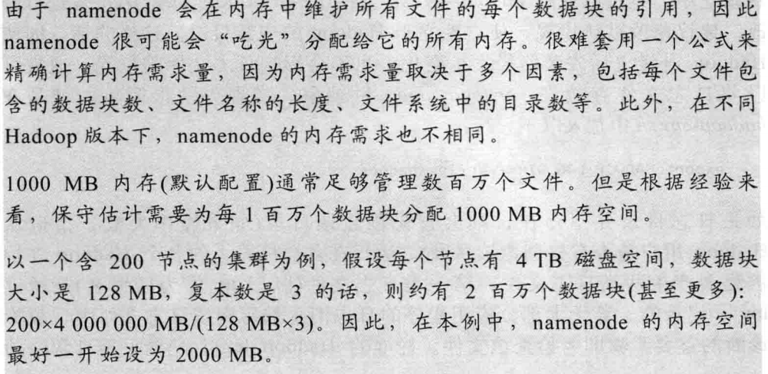

## 安全模式

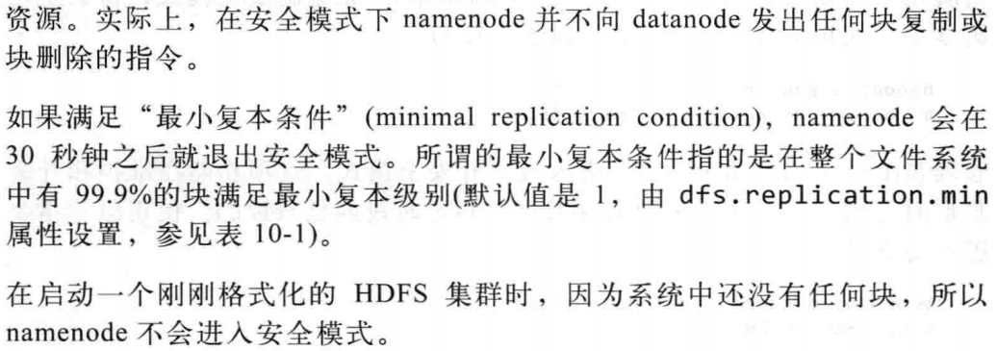

## HDFS Short-Circuit Local Reads 短路本地读取

<http://hadoop.apache.org/docs/r2.7.3/hadoop-project-dist/hadoop-hdfs/ShortCircuitLocalReads.html>

当client请求数据时，datanode会读取数据然后通过TCP协议发送给client.short-circuit绕过了datanode直接读取数据。**short-circuit的前提是client和数据在同一个结点上。**

short-circuit需要libhadoop.so，一个本地库。该功能使用unix套接字，client和node通过套接字连接，需要对这个套接字设置一个路径，并且datanode有创建这个路径的权限，一般建在/var/run或者/var/lib。client和datanode通过共享内在/dev/shm交换数据。

client和datanode都要进行配置；

Example Configuration

Here is an example configuration.

<configuration>

<property>

<name>dfs.client.read.shortcircuit</name>

<value>true</value>

</property>

<property>

<name>dfs.domain.socket.path</name>

<value>/var/lib/hadoop-hdfs/dn_socket</value>

</property>

</configuration>

旧式的short-circuit本地读依然被支持，但是配置不一样，要注意其安全性：

<configuration>

<property>

<name>dfs.client.read.shortcircuit</name>

<value>true</value>

</property>

<property>

<name>dfs.client.use.legacy.blockreader.local</name>

<value>true</value>

</property>

<property>

<name>dfs.datanode.data.dir.perm</name>

<value>750</value>

</property>

<property>

<name>dfs.block.local-path-access.user</name>

<value>foo,bar</value>

</property>

</configuration>